**LBJ-Case Study-1**

**1) Develop a standalone console-based Java/C#/Python application which will manage various colleges across the state.**

Java standalone console-based application for managing various colleges across the states.

**Project Structure**



**App.java**

This java programs consists the main method which is the entry point to the program. The main method consists of a switch case that does the following operations

1) Register new college.

2) Display colleges in Mumbai who teach Engineering.

Apache common csv library is used to traverse the whole csv and find the records whose courseType is “Engineering” and city is “Mumbai”. It returns a CSVRecord Object which consists the matching records.

3) Remove college based on collegeID.

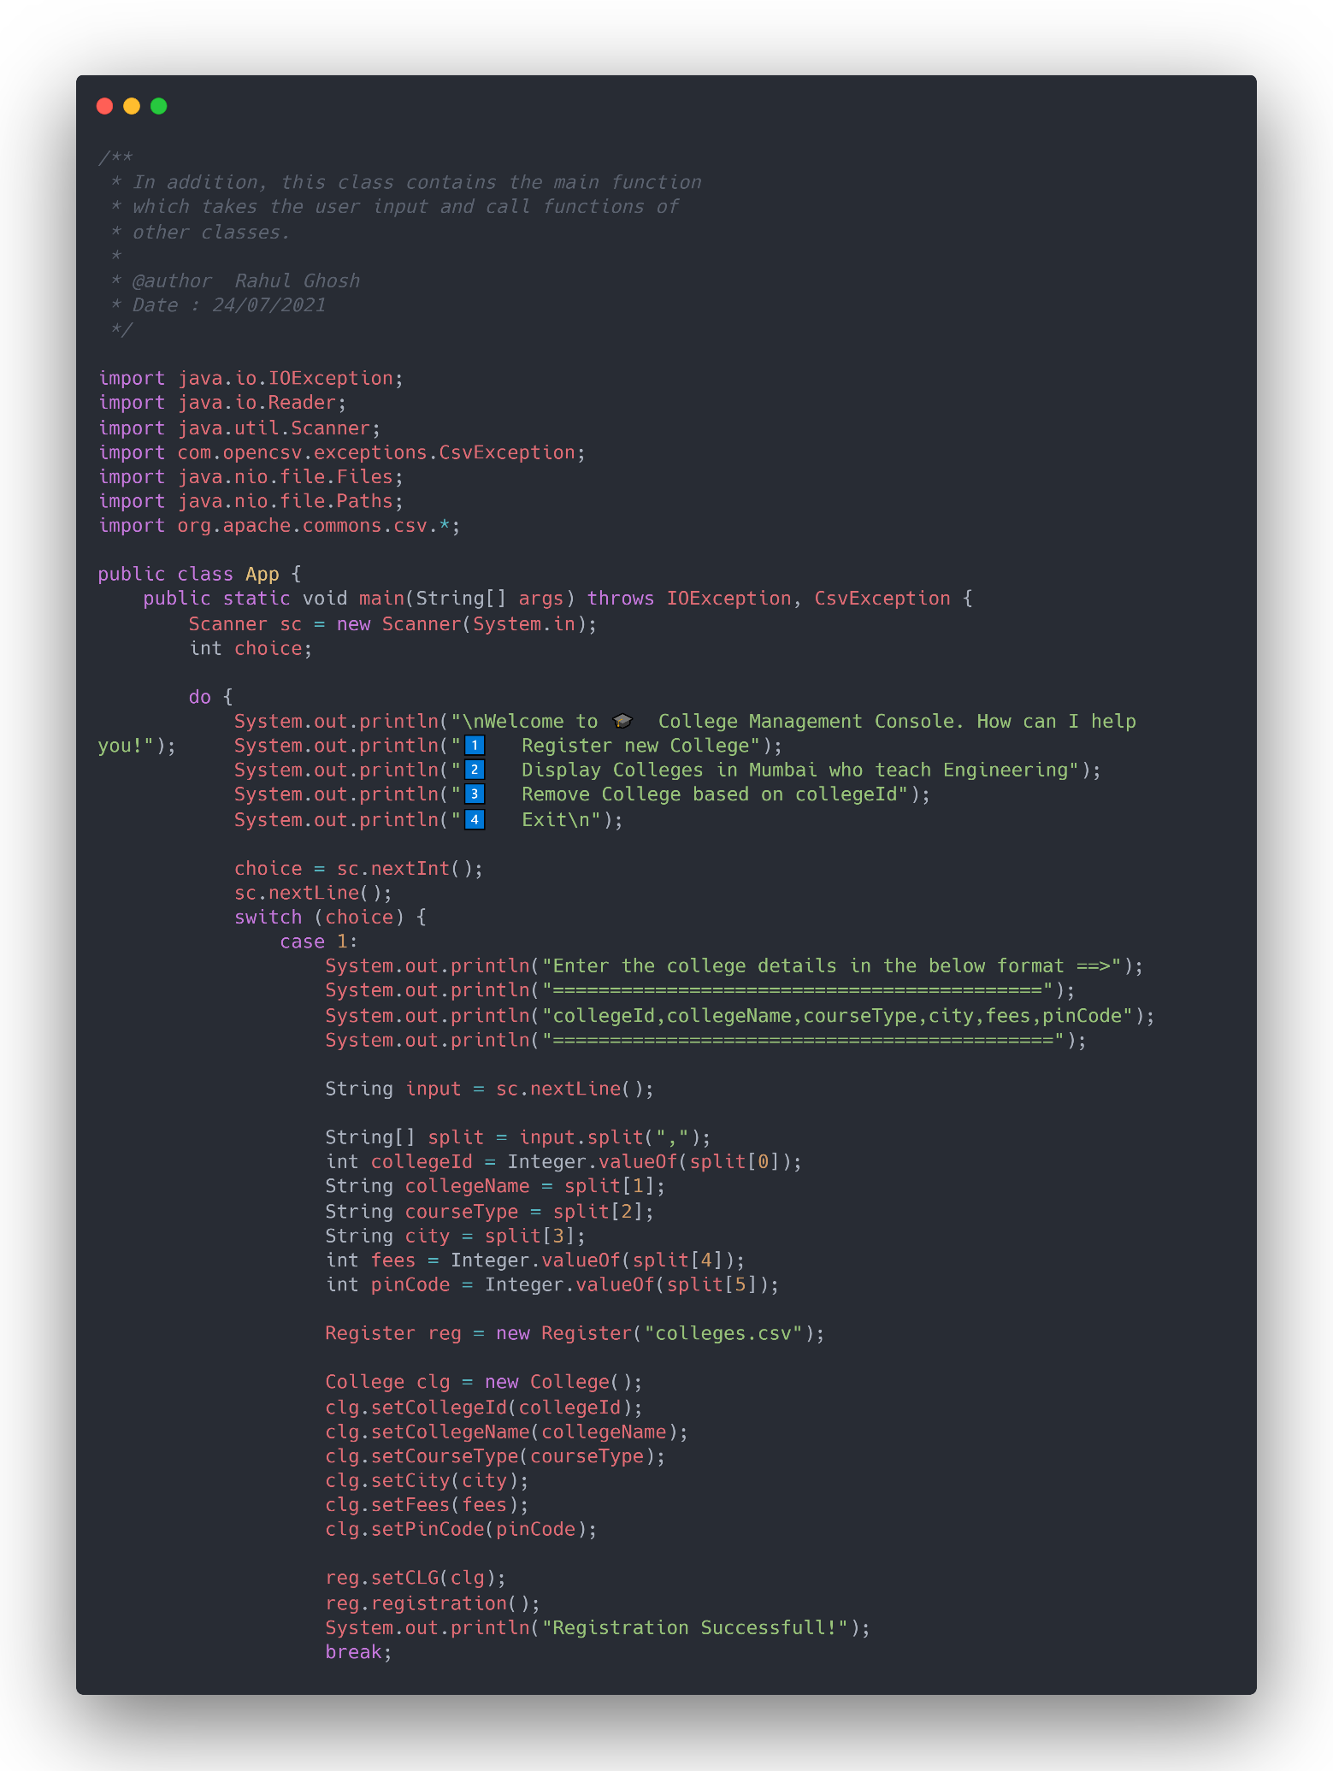

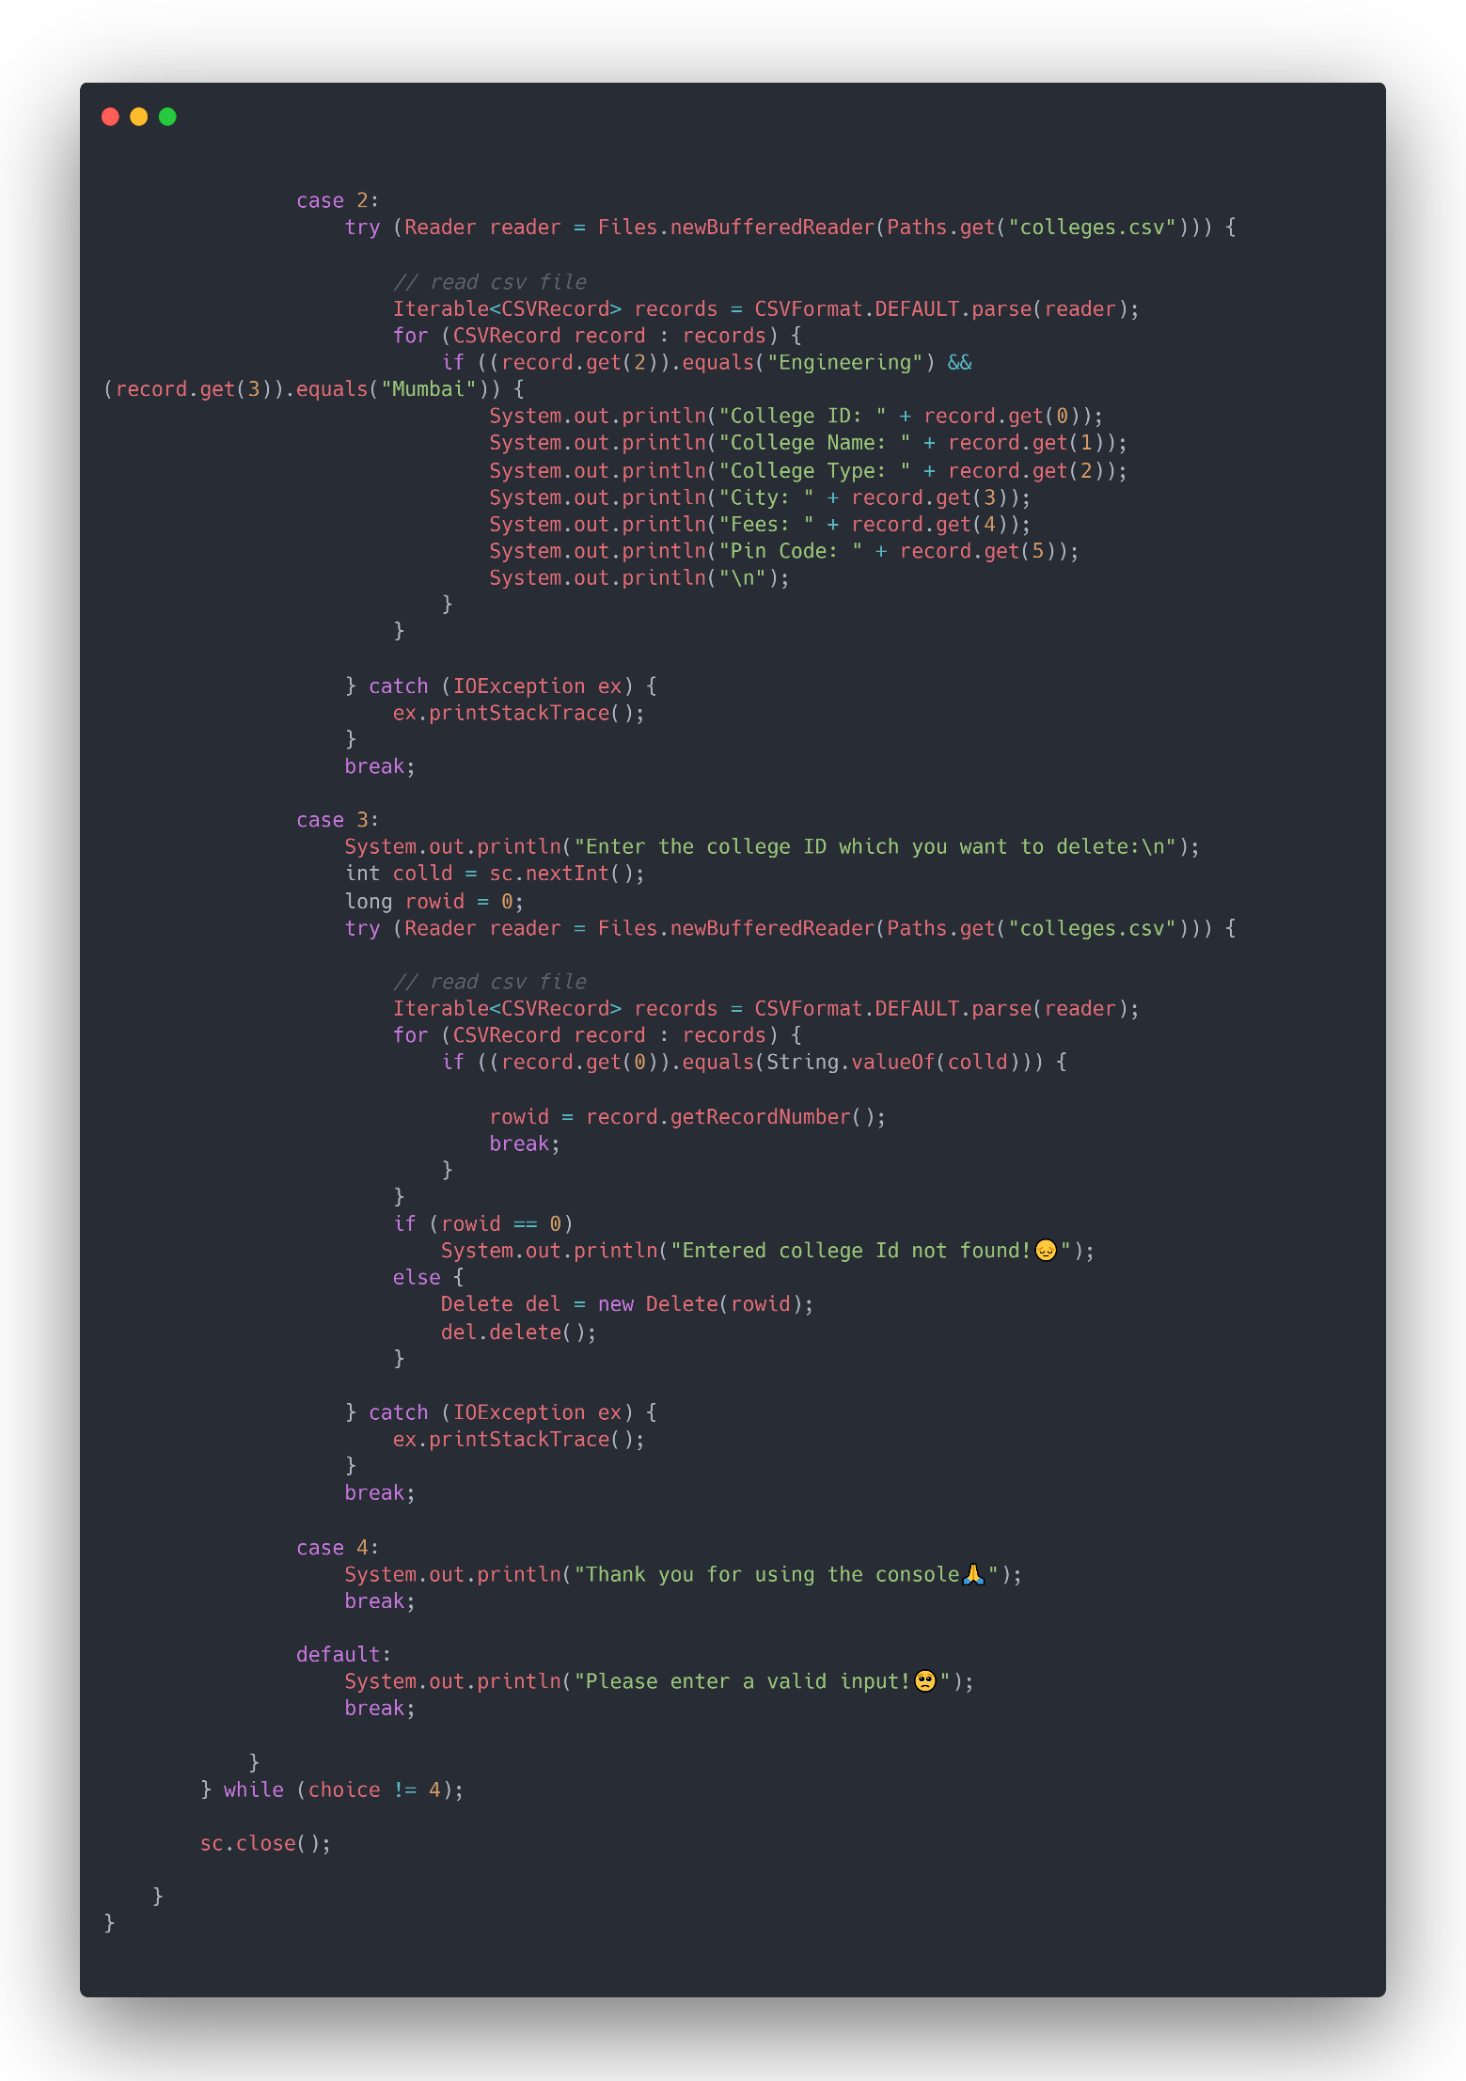

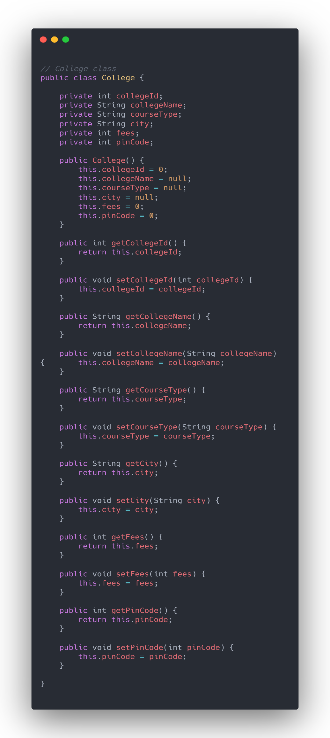

College.java

The college class has the following attributes which are private:

* College ID
* College Name
* Course Type
* City
* Fees
* Pin code

It also consists of a constructor which initialises all the attribute values.

Along with the constructor it consists getter and setter methods (accessor and mutator) for accessing and updating the variable values.

**Register.java**

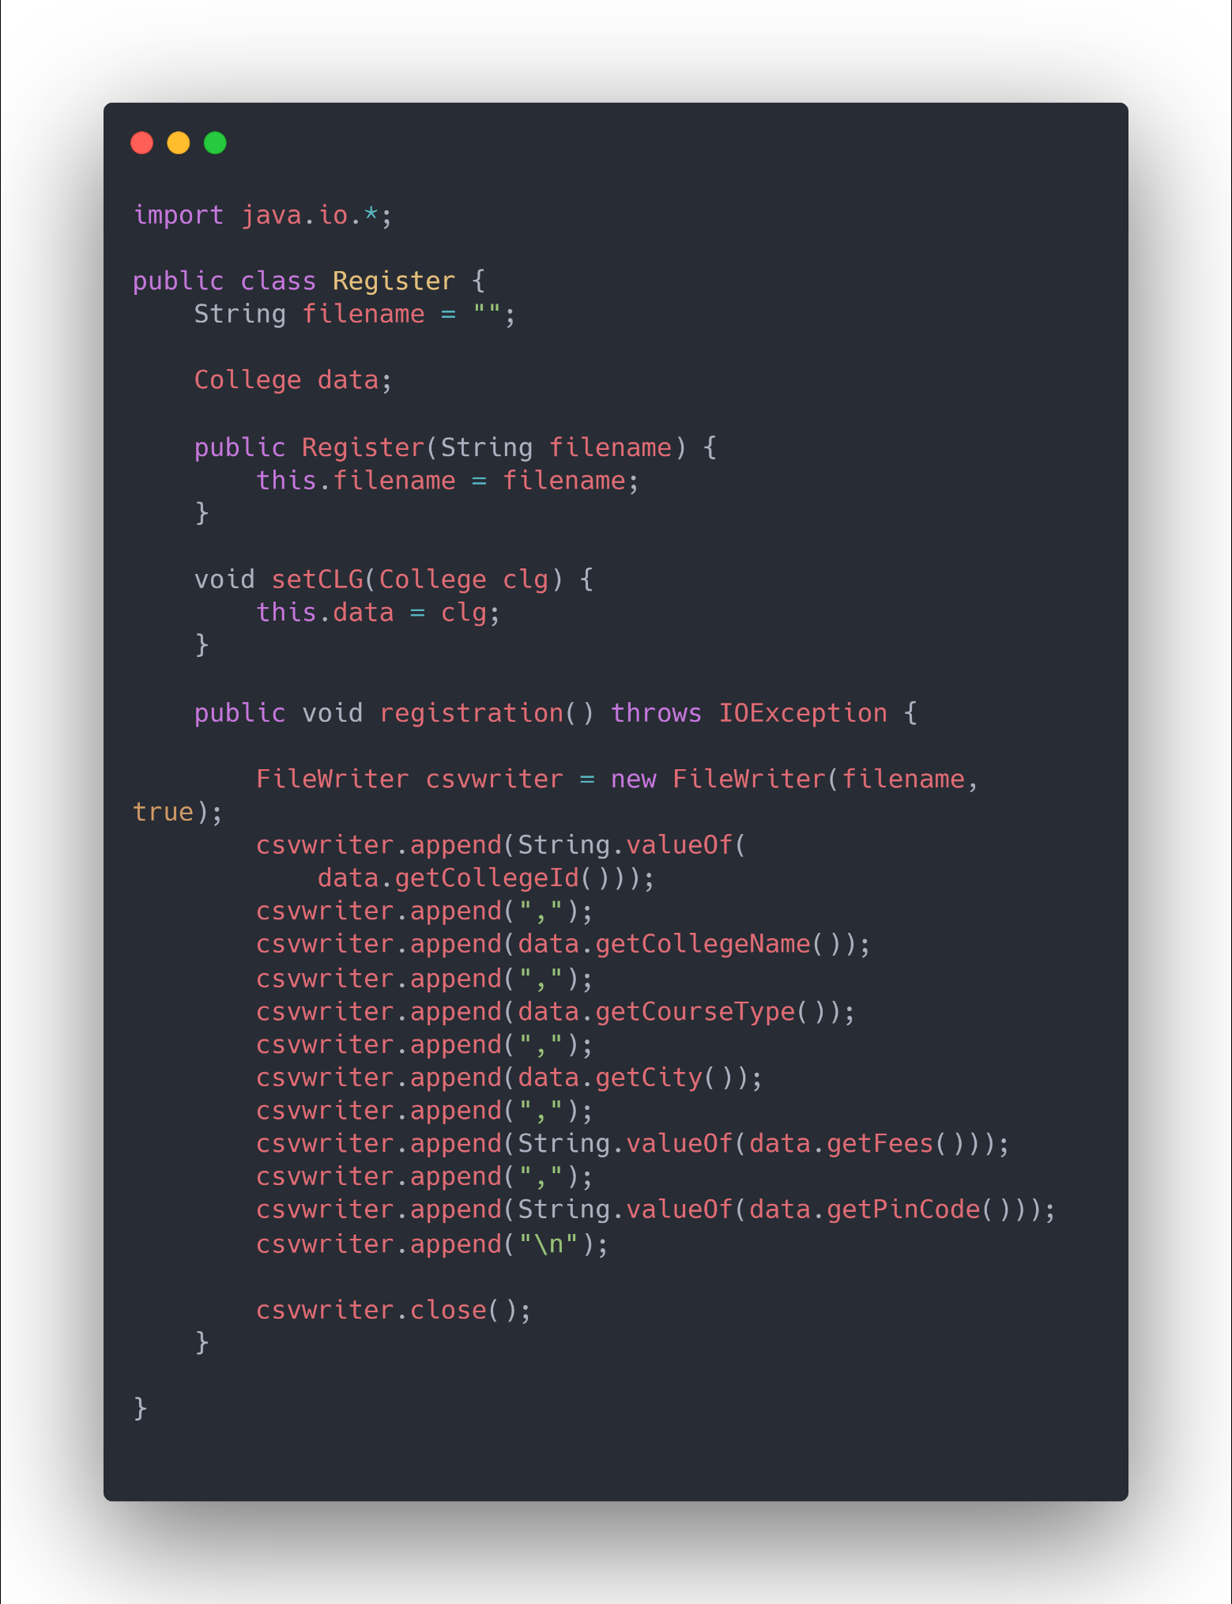 The Register class consists of methods which help in registering the college in the csv. After the inputs are taken from the user, the registration method is called. A Filewriter object is created which is used to append the user input college data to the csv.

**Delete.java**

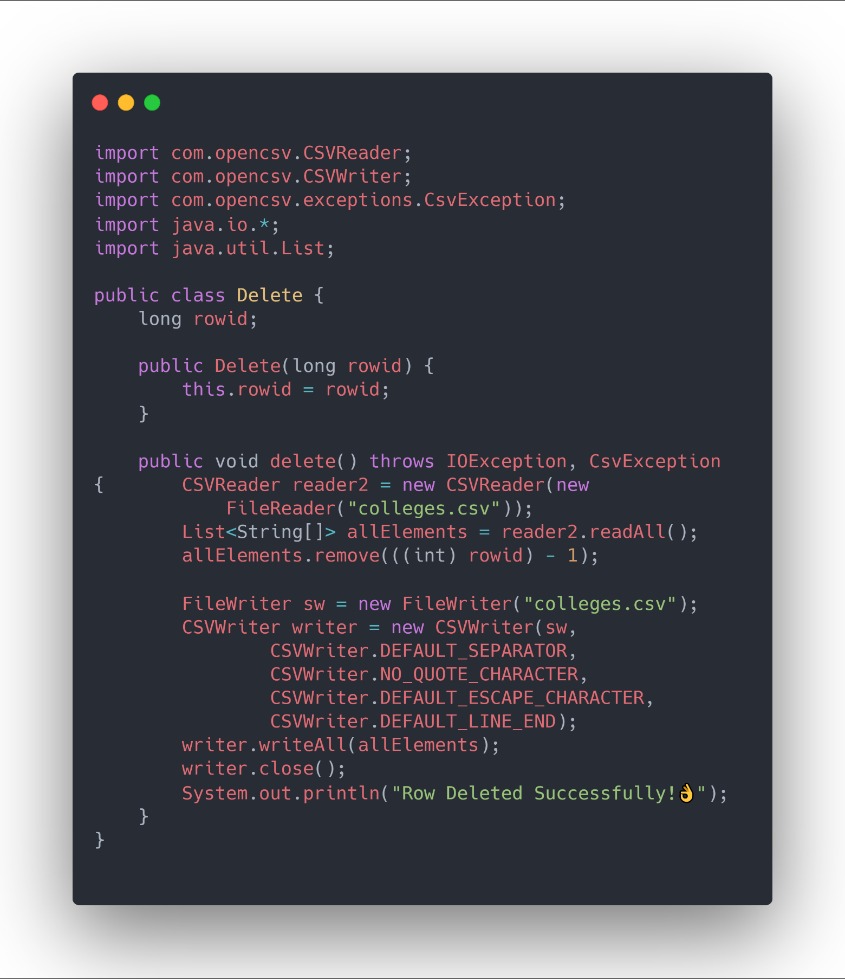The Delete class consists of the methods to remove the college record from the csv file. Opencsv is used to attain this functionality. It is easy-to-use CSV (comma-separated values) parser library for Java.

**OUTPUT:**

**Initial data in colleges.csv**

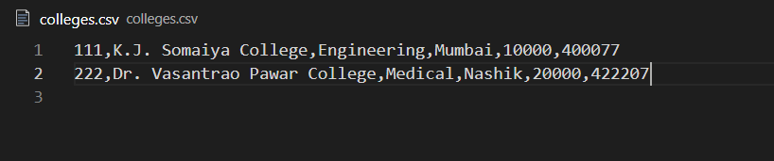

**1)Registration**

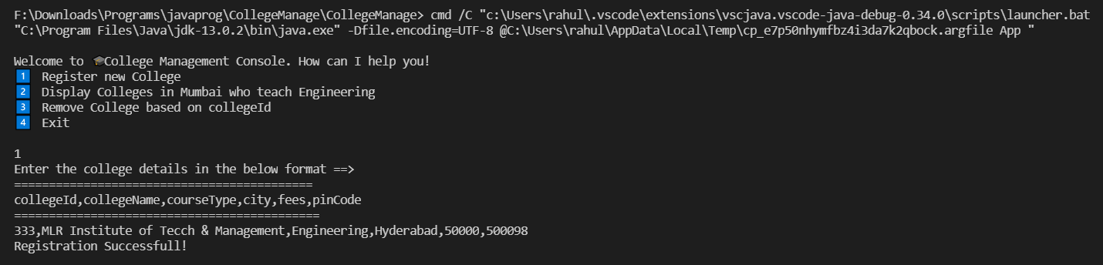

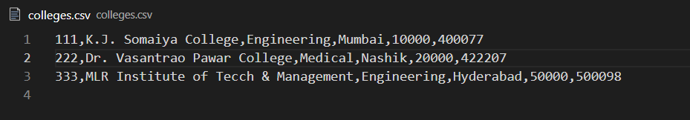

**2) Display**

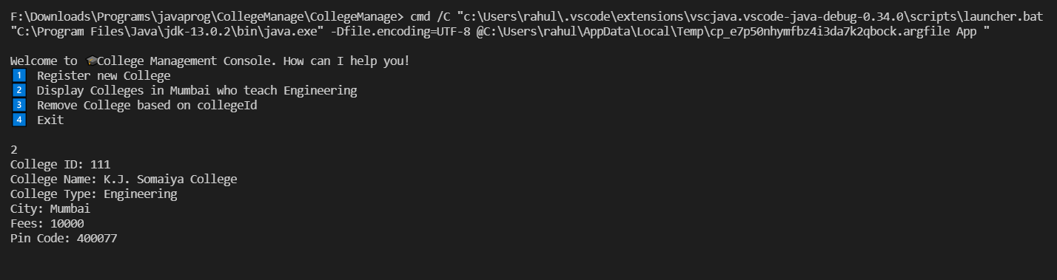

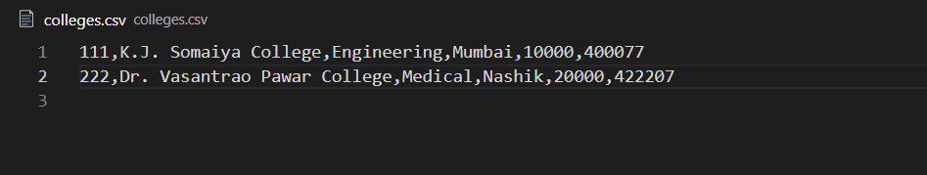**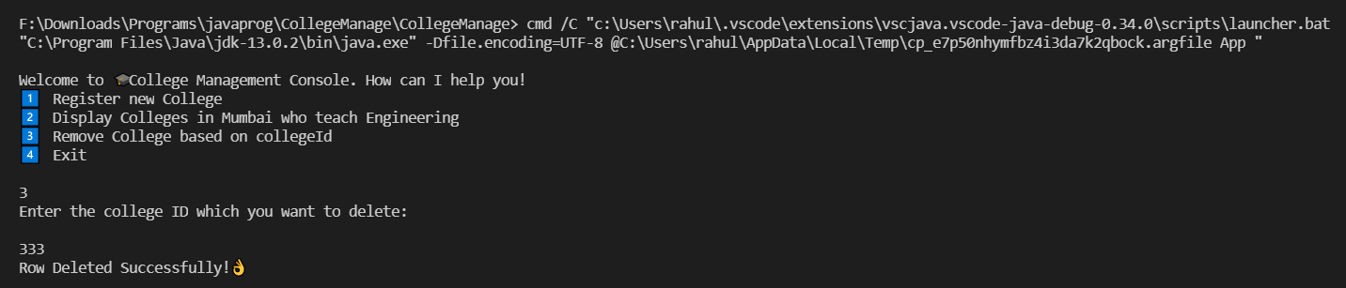3) Remove**

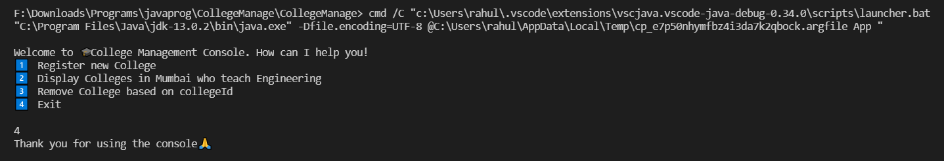**4) Exit**

The source code for both the projects are available here👇

<https://github.com/rahulghosh8341/LBJ-CaseStudy-1.git>

**2) Create a Login page using HTML.**

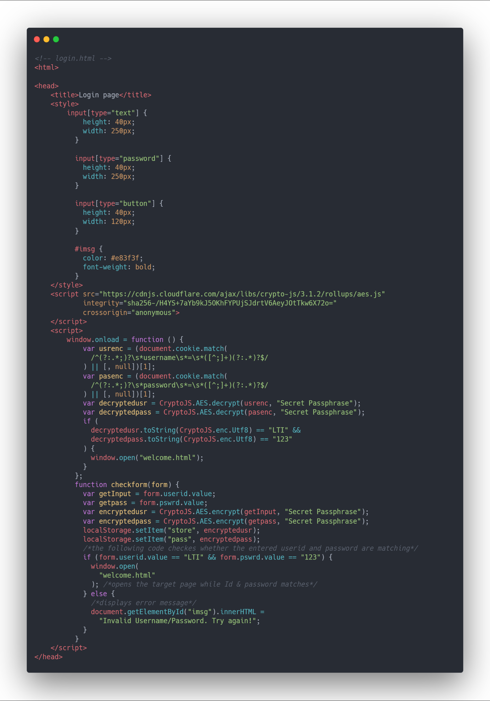**Source Code:** login.html

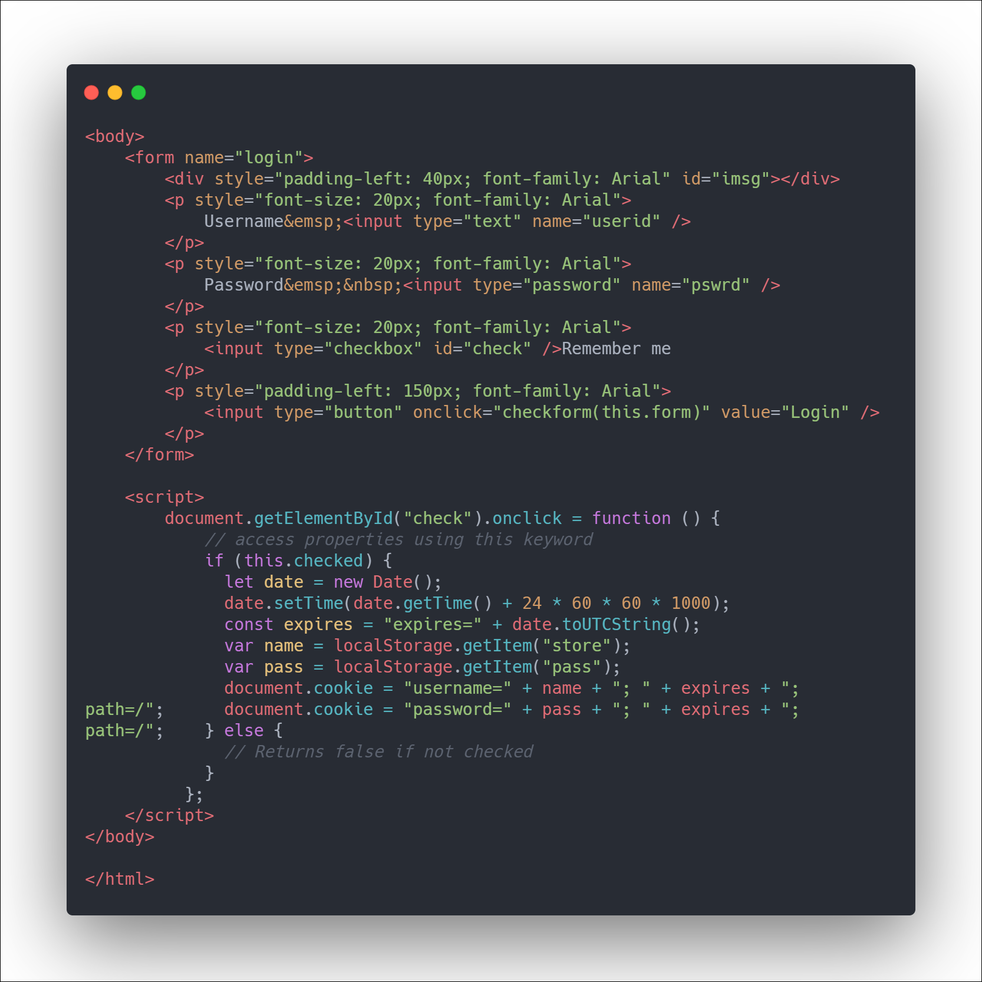

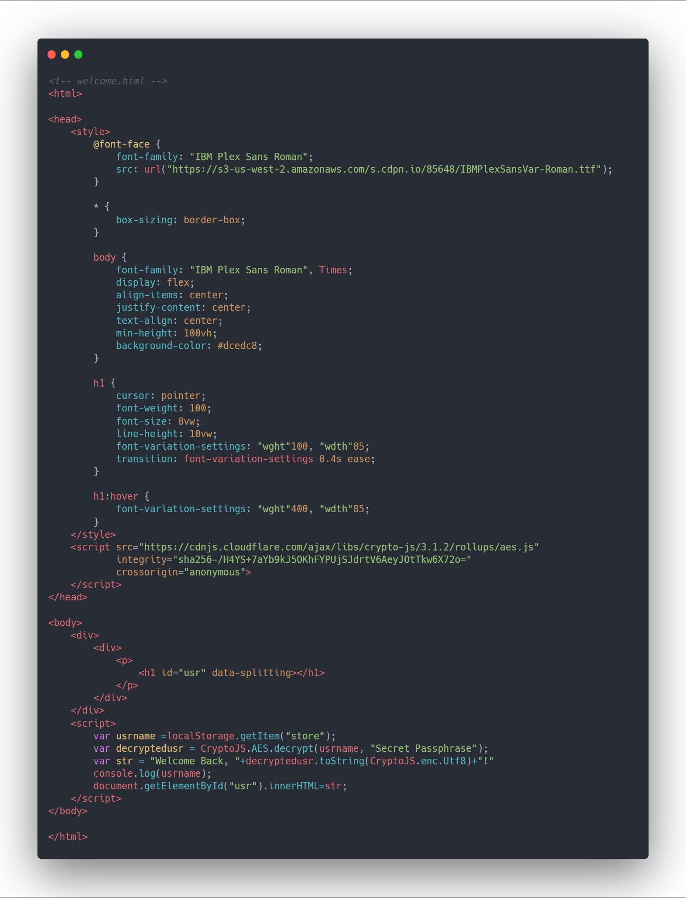**Welcome.html**

**OUTPUT:**

Login page

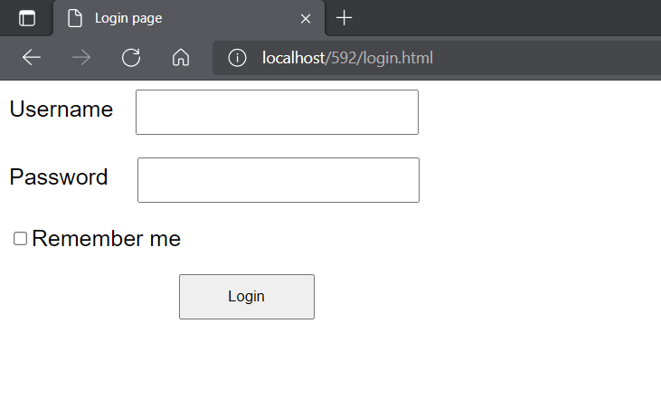

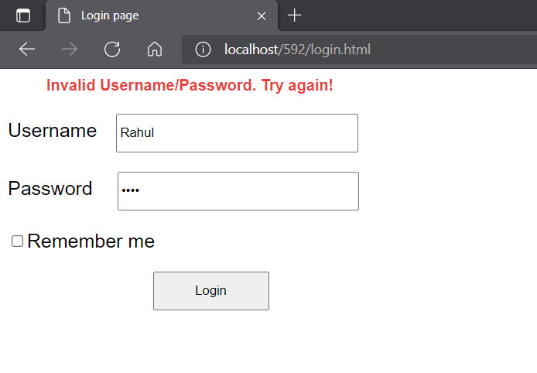Javascript form validation

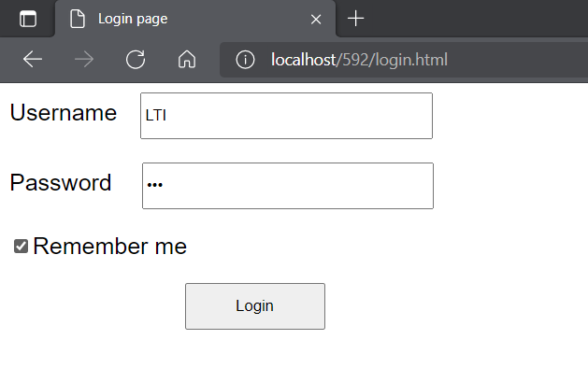Homepage after successful login.

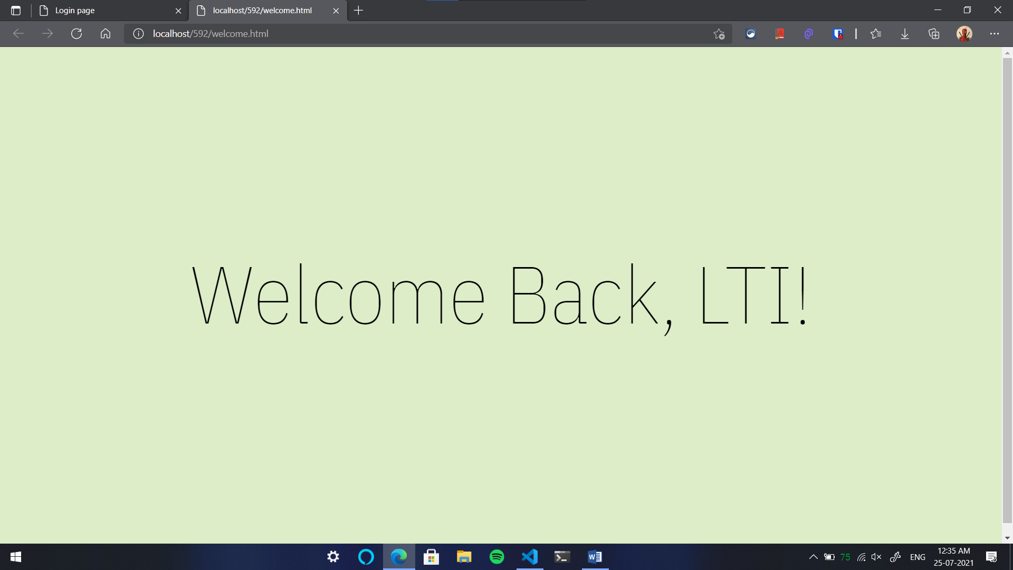Watch the webpage in action: <https://media.giphy.com/media/zvTKfZLpdxZOn4xtFn/source.mp4>

The user can also select the remember me checkbox while entering the credentials, to automatically transfer to the homepage. The username and password are encrypted and stored in the cookies for 1 day. When the user revisits the login page, it checks for the cookies, decrypts it and validates it. If the data is valid it redirects to the homepage automatically.

The cookies stored for username and password are shown below. The cookies would expire in 24 hrs. CryptoJS is used for encryption and decryption of username and password.

You can view the remember me functionality here👇:

<https://media.giphy.com/media/JnU3P86DXkMG5gSb4g/source.mp4>

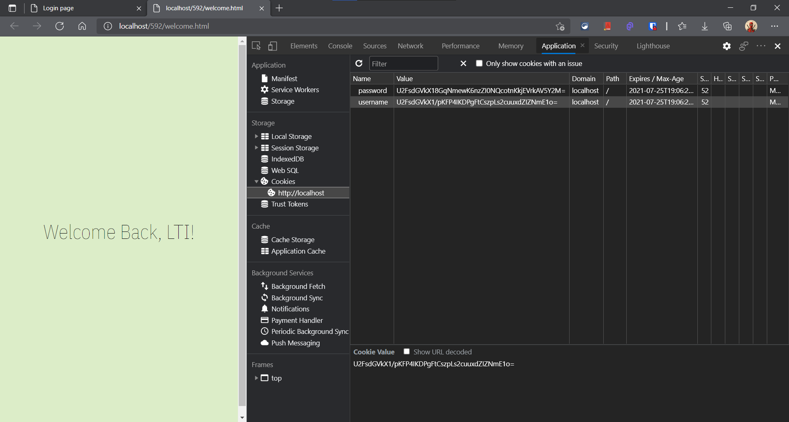

The source code for both the projects are available here👇

<https://github.com/rahulghosh8341/LBJ-CaseStudy-1.git>